Basic relationship

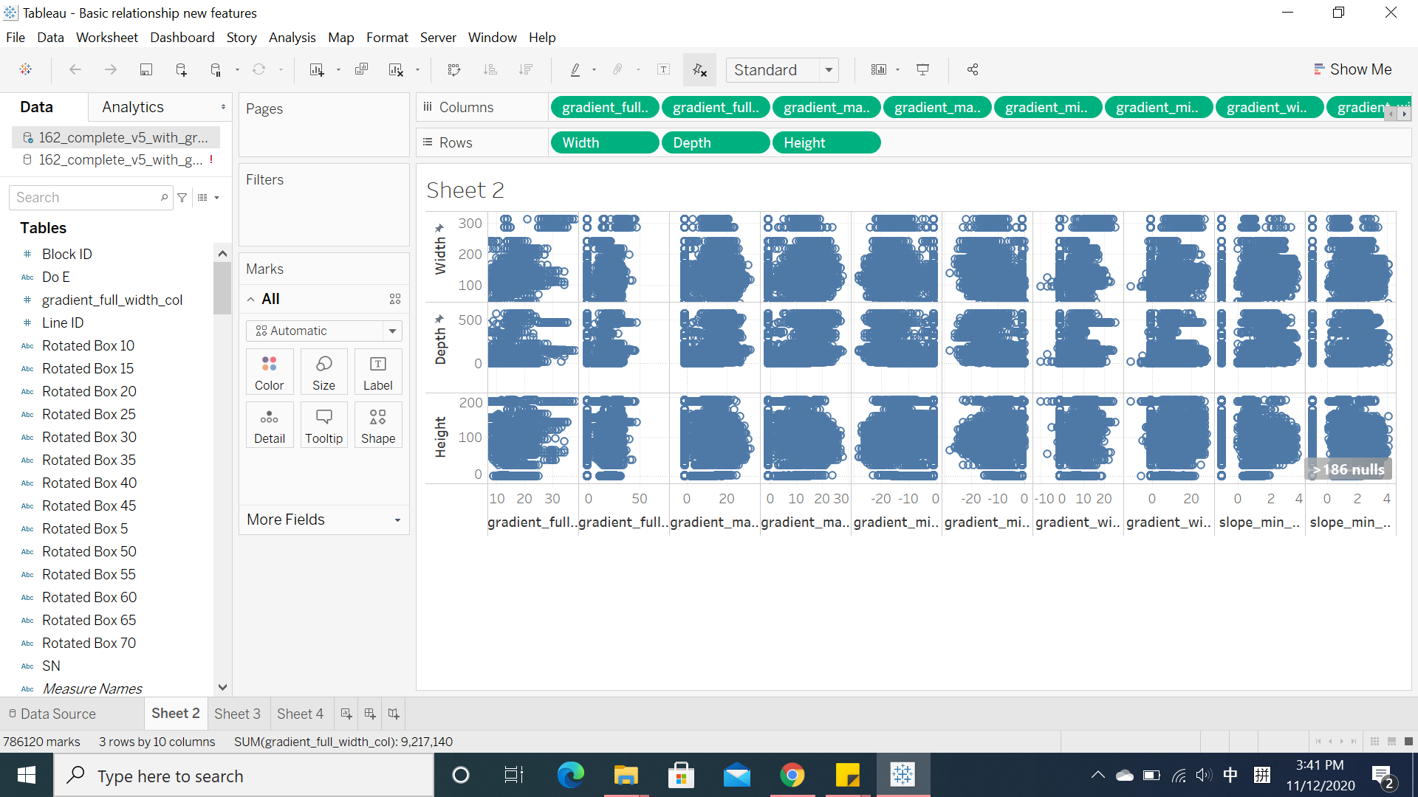

gradient _max_value_col

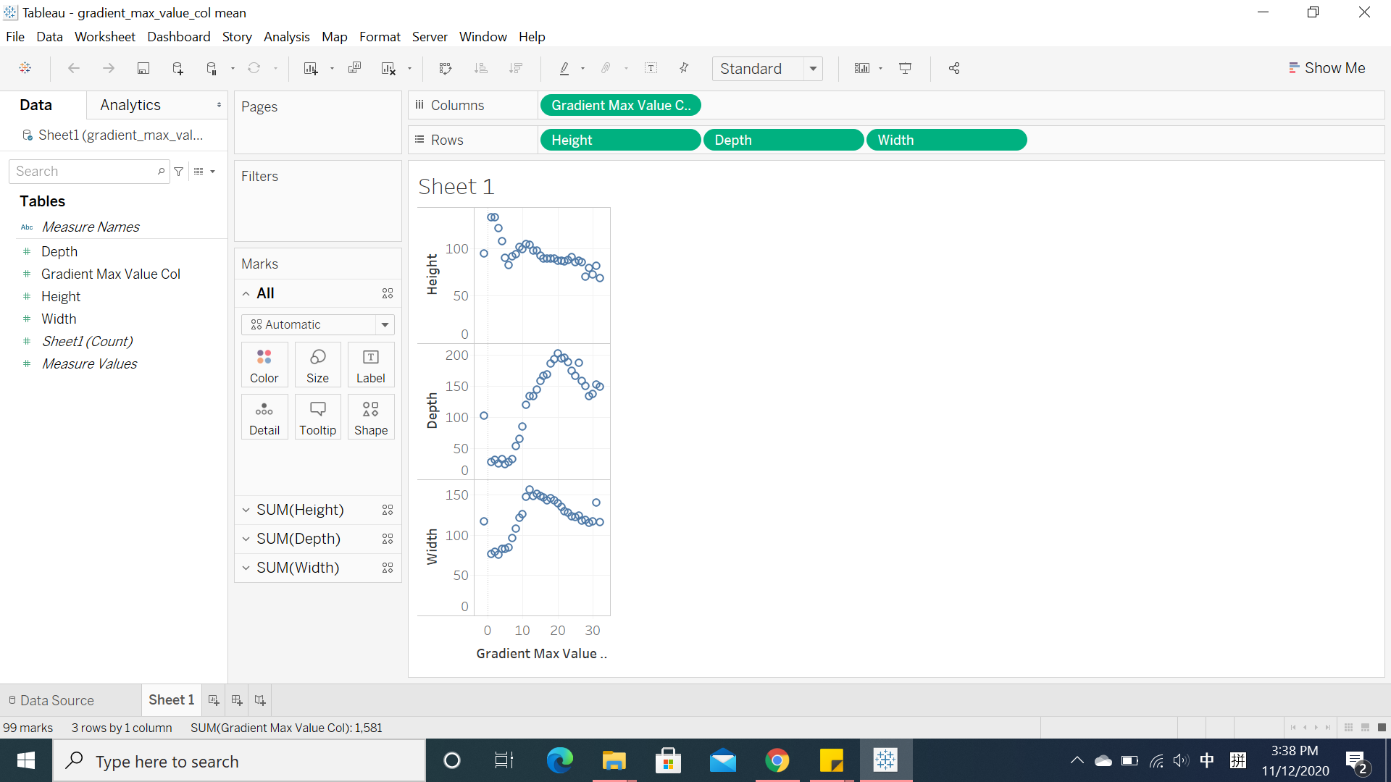

|  |
| --- |
| gradient_min_value_col |

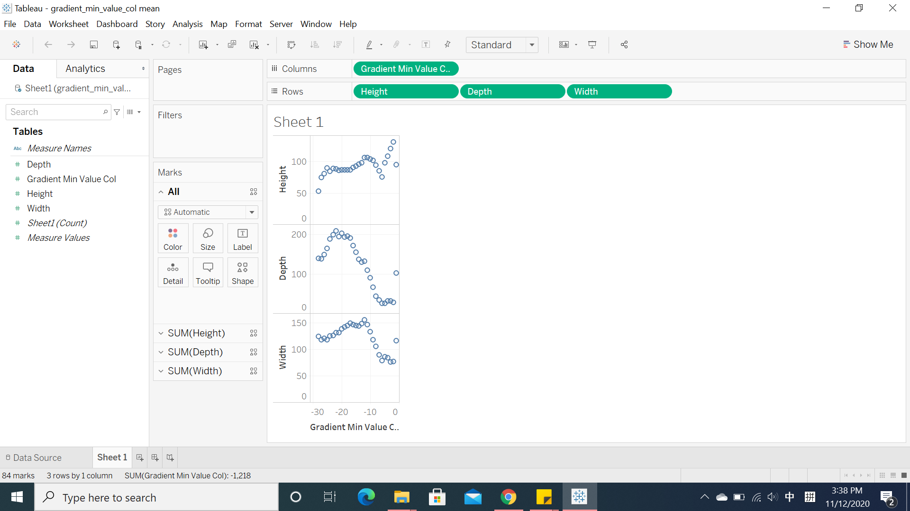

Gradient_Width_col

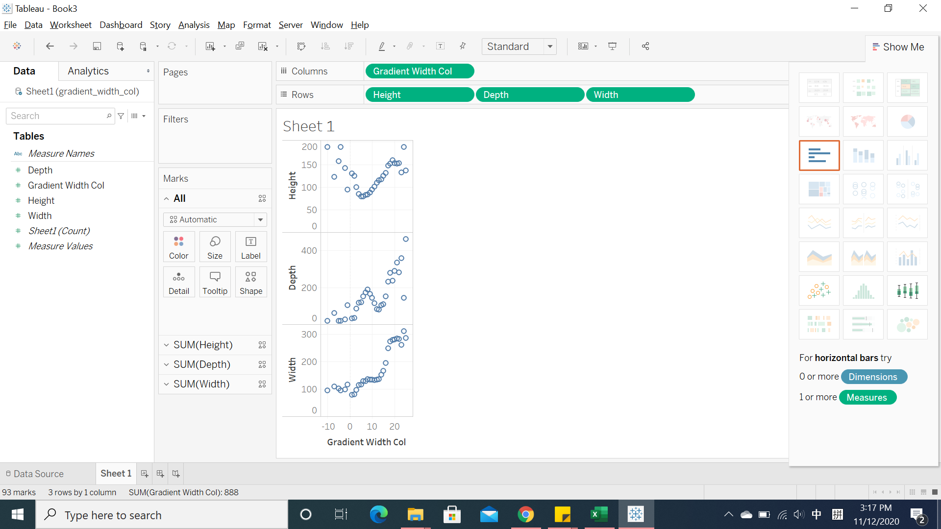

**Gradient full width col**

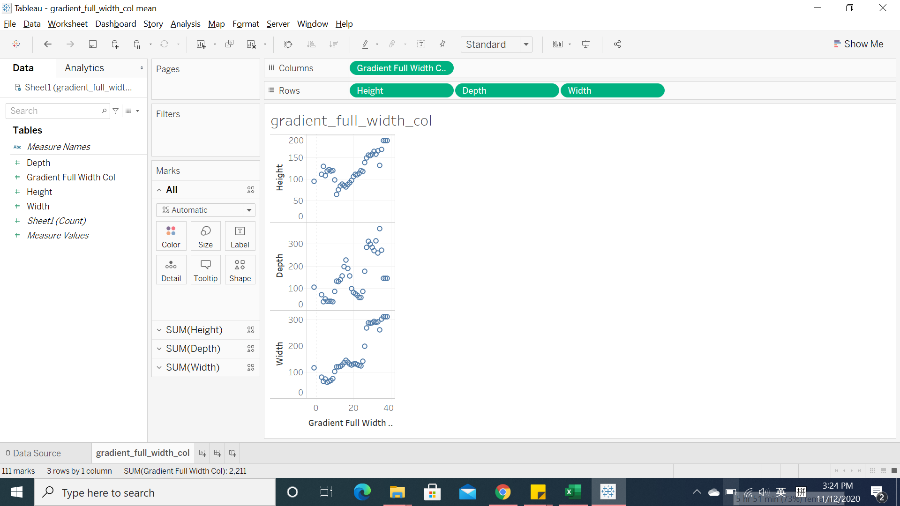

**Slope_min_max_col**

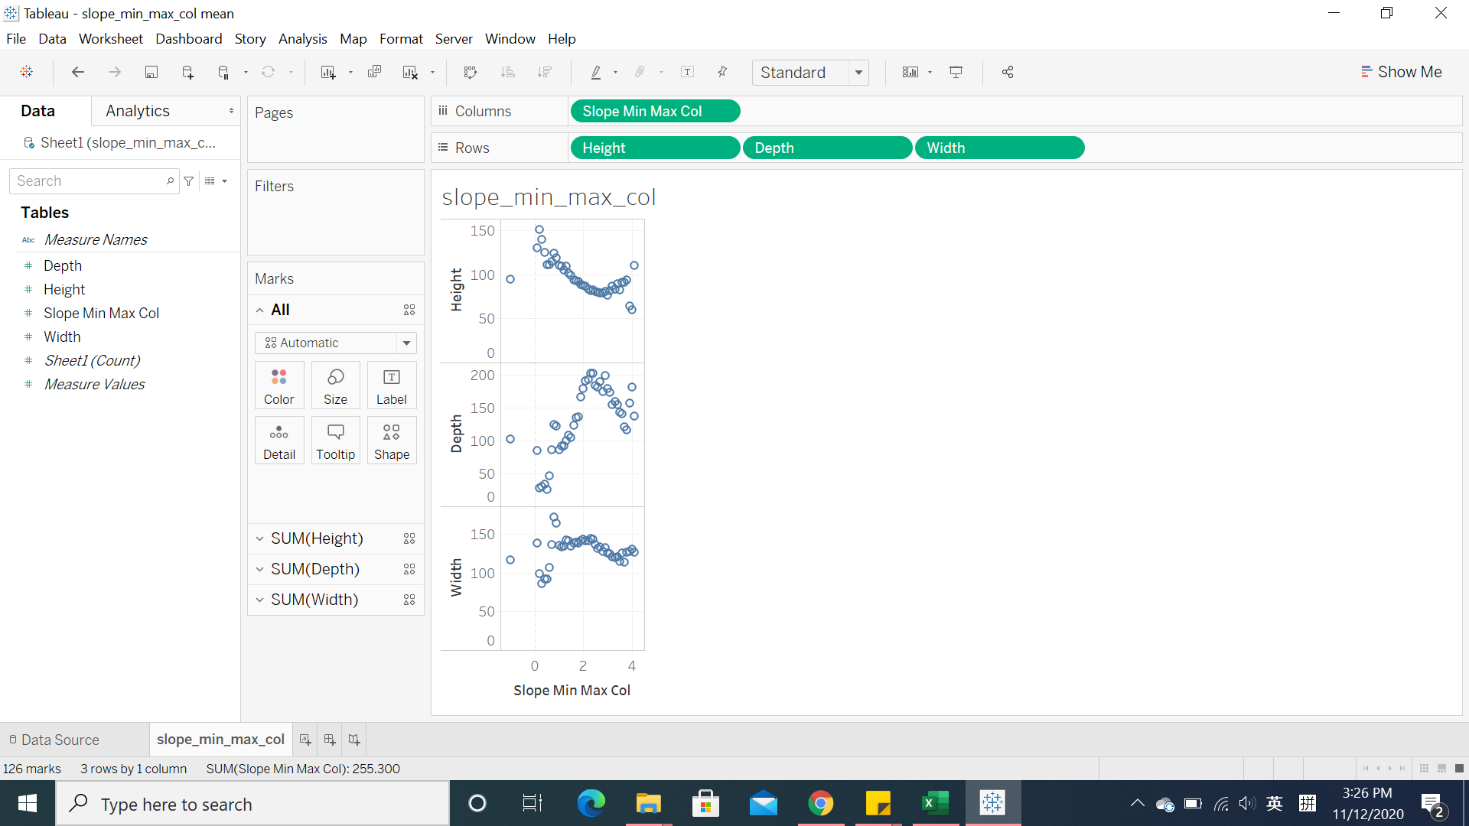

**Gradient_max_value_rows**

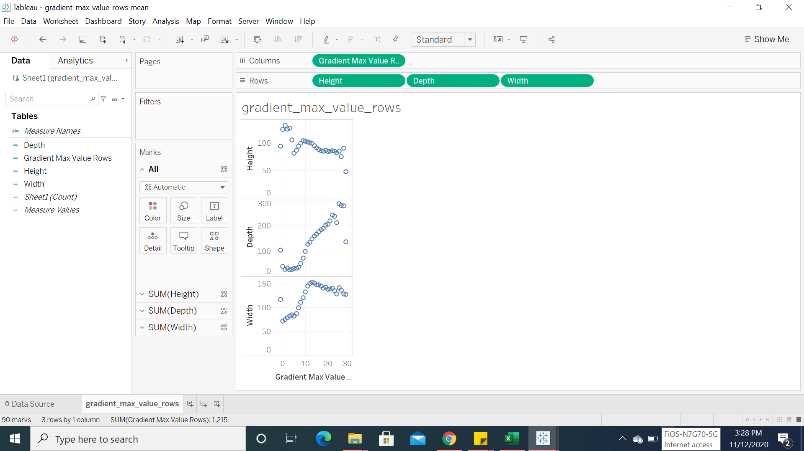

**Gradient_min_value_rows**

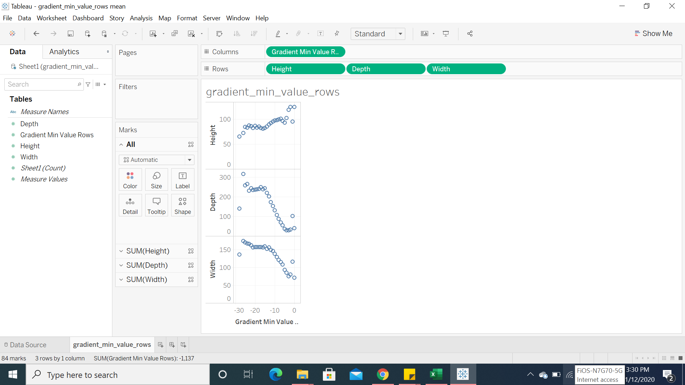

**Gradient_width_rows**

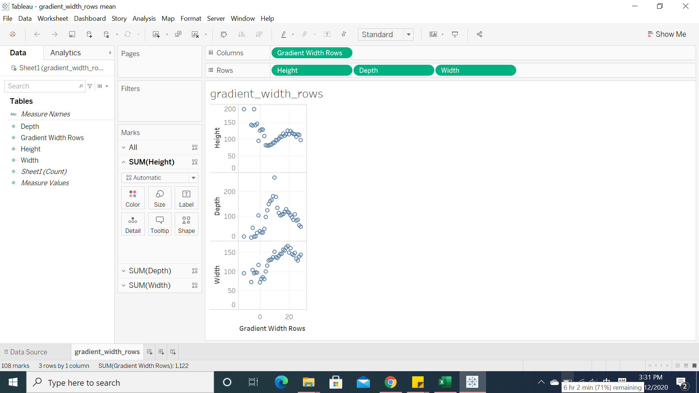

**Gradient_full_width_rows**

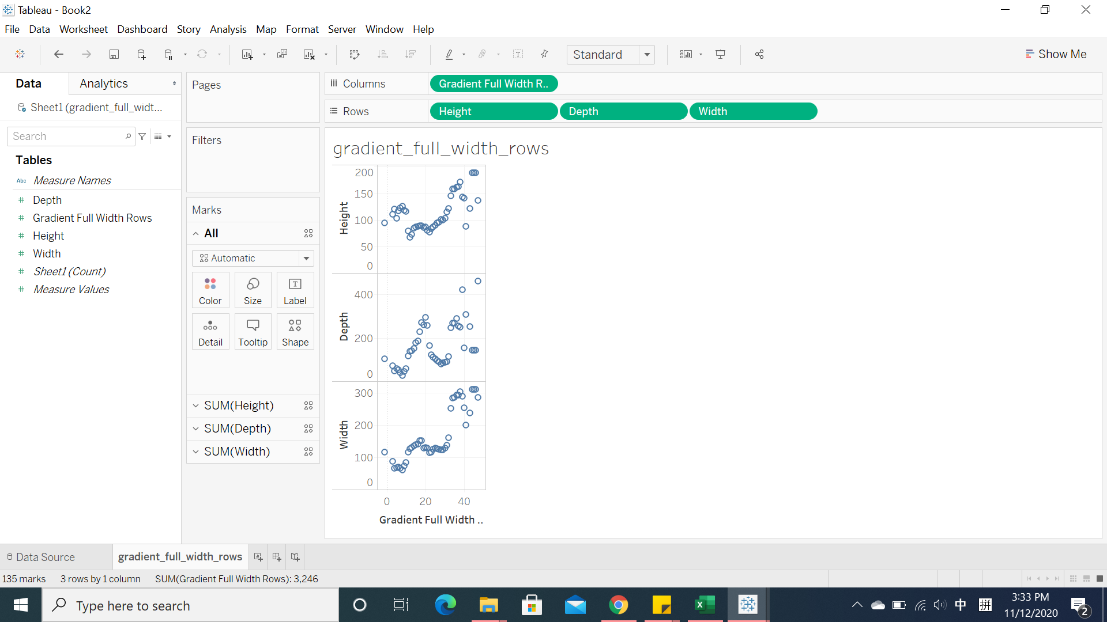

**Slope_min_max_rows**



  
  
  

  
  
  